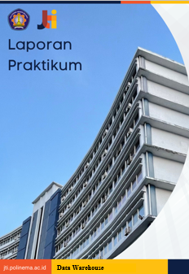

NIM

No Absen

Nama Lengkap

Daftar Isi

Use this style for TOC Level 1 / Chapter (Bab) 3

Use this style for TOC Level 2 / Sub Chapter (Sub Bab) 3

Use this style for TOC Level 3 / Sub Sub Chapter (Sub Sub Bab) 3

# Use this style for TOC Level 1 / Chapter (Bab)

## Use this style for TOC Level 2 / Sub Chapter (Sub Bab)

### Use this style for TOC Level 3 / Sub Sub Chapter (Sub Sub Bab)

Gunankan style normal untuk paragraph.